INTERNSHIP PROGRESS REPORT II

**About D365 and PowerApps**

D365 and PowerApps are two Microsoft technologies that can be used together to create customized business solutions. Here's a more detailed explanation of each technology:

D365, also known as Dynamics 365, is a cloud-based enterprise resource planning (ERP) and customer relationship management (CRM) software. It provides a suite of applications that businesses can use to manage their financials, sales, marketing, operations, and more.

D365 can be used to:

* Automate business processes and workflows
* Collect and analyze data to gain insights into business operations
* Manage customer relationships and improve customer experiences
* Manage financials and optimize financial processes
* Manage supply chain operations
* Manage projects and optimize project-based operations
* Manage field service operations

PowerApps, on the other hand, is a low-code app development platform that enables users to create custom business applications without writing code. PowerApps allows businesses to build custom applications to meet their unique needs, connect to data sources, and automate workflows.

With PowerApps, businesses can:

* Build custom applications that integrate with D365 data and processes
* Connect to various data sources, such as SharePoint, SQL Server, and Excel
* Automate workflows, such as approvals and notifications
* Use AI and machine learning to enhance their applications

PowerApps can be used in conjunction with D365 to create custom apps that integrate with D365 data and processes. For example, a business might create a custom app to streamline their sales process, allowing sales reps to create quotes and orders directly from their mobile devices.

Overall, the combination of D365 and PowerApps allows businesses to create custom solutions that meet their specific needs and streamline their operations. With the low-code nature of PowerApps, businesses can create these solutions quickly and with less reliance on IT departments.

**Model Driven Apps and Canvas Apps**

Model-driven apps and canvas apps are two types of applications that can be built using the Power Apps platform from Microsoft. Here's a brief overview of each:

*Model-driven apps*: These apps are built using a model-driven approach, meaning that they are based on a data model created in the Common Data Service (CDS). Model-driven apps are typically used to build applications that have a structured data model, such as customer relationship management (CRM) or enterprise resource planning (ERP) systems. These apps provide a consistent user interface and can be easily customized to meet specific business requirements.

*Canvas apps*: These apps are built using a canvas-based approach, meaning that they are created by dragging and dropping various components onto a blank canvas. Canvas apps are typically used to build applications that have a more flexible user interface and data model, such as custom data entry or inspection applications. Canvas apps are highly customizable, and users can add features such as charts, maps, and media controls to the application.

Both model-driven and canvas apps can be created using Power Apps, and each type of app has its own set of benefits and drawbacks. Model-driven apps are typically faster to create and easier to maintain, but they may be less flexible than canvas apps. Canvas apps, on the other hand, can be more complex to create but offer more customization options and can be more adaptable to specific business needs.

Overall, Power Apps provides a flexible platform for building custom applications, and businesses can choose the type of app that best fits their requirements and skillsets.

**Problem Identification**

Some of the key area of focus is to develop a applications that enables businesses to build custom applications to solve a wide range of problems. Here are some common problems that PowerApps can help to solve:

* Automate processes: We help businesses automate manual processes, such as data entry or form filling. By automating these processes, businesses can save time and reduce the risk of errors.
* Data silos: We help businesses to break down data silos by consolidating data from different sources into a single application. This can help to provide a more complete view of business data and enable better decision-making.
* Limited IT resources: We help businesses to build custom applications without requiring a large IT team. With its low-code approach, even non-technical users can build custom applications, reducing the burden on IT resources.
* Lack of customization: We help businesses to create custom applications tailored to their specific needs. This can help to fill gaps in off-the-shelf software solutions that may not provide the required level of customization.
* Data security: PowerApps can help businesses to ensure data security by providing a secure platform for building custom applications. Businesses can control access to the application and ensure that sensitive data is protected.

**Objective**

Our main Aim is Deliver the state of the art application that automate processes, improve productivity, and provide insights into business data. Here are some common use cases for PowerApps:

* Customer Relationship Management (CRM): PowerApps can be used to create custom CRM systems that manage customer information, sales pipelines, and marketing campaigns.
* Field service: PowerApps can be used to build field service applications that enable field technicians to manage service orders, schedule appointments, and track inventory.
* Inventory management: PowerApps can be used to create inventory management systems that track stock levels, manage purchase orders, and streamline supply chain operations.
* Human Resources (HR): PowerApps can be used to build custom HR applications that manage employee data, performance reviews, and benefits.
* Financial management: PowerApps can be used to create financial management systems that manage accounting processes, including invoicing, expenses, and budgeting.
* Incident management: PowerApps can be used to build custom applications that manage incident reports, including health and safety incidents, IT outages, and security breaches.
* Compliance management: PowerApps can be used to build custom applications that manage compliance requirements, including audits, regulatory compliance, and risk management.
* Project management: PowerApps can be used to create project management systems that manage tasks, schedules, budgets, and team collaboration.

Overall, PowerApps can be used to build custom applications that streamline business operations, improve efficiency, and provide valuable insights into business data. With its low-code approach, PowerApps enables businesses to build these custom applications quickly and easily, even with limited technical expertise.

**Solution Provided.**

We develop the applications to solve business problems and help with the automation of tasks. We provided our contribution in PowerApps verticals more specifically in Canvas Apps, Model Driven Apps and Power Automate. We create an state of the art applications under the supervised guidance of Industry experts like Sr Analyst, Consultant and Technical Architects. Our main Aim was to deliver applications which can help business grow and automate the manual tasks.

We build the application to track the resources of a Mumbai division of firm. Which can help us to track the billing of each resources. The tech we used for this is PowerApps, model driven apps and Power automate. Some of the demo work is attached below as a snippets. Detail Information can’t be provided under the confidential policies of firm.

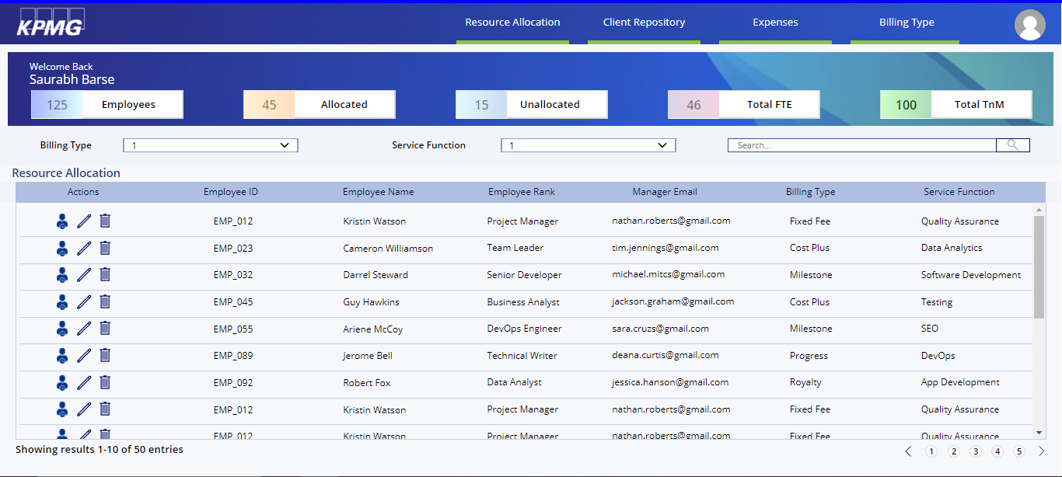

Dashboard for Client

Note: Can’t show work in detail due to company confidential policy

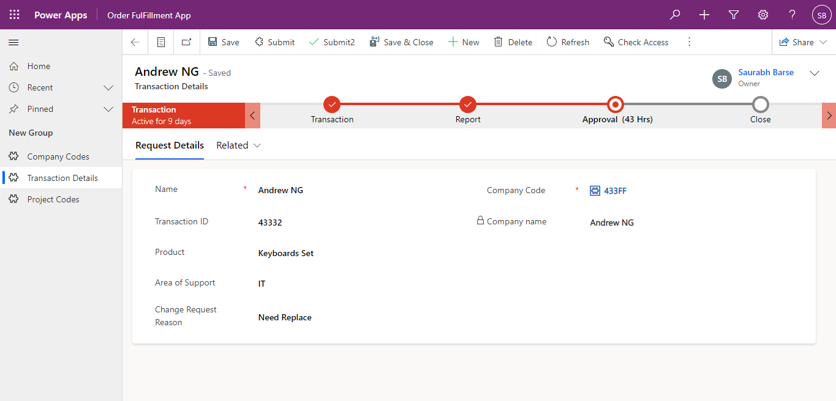

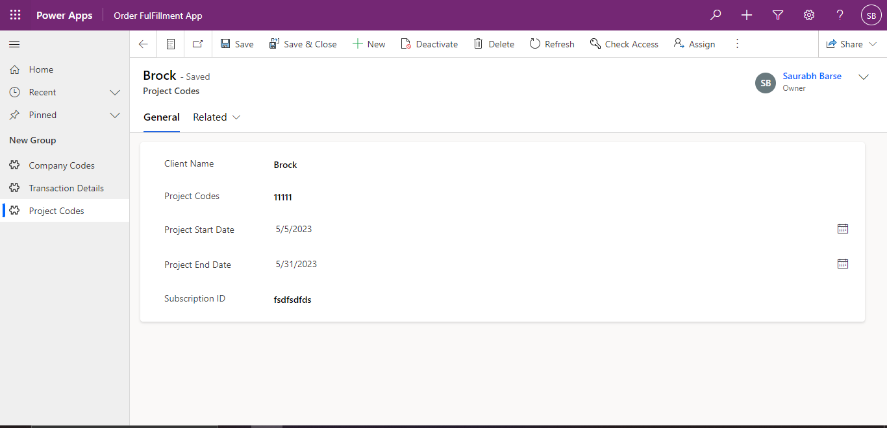

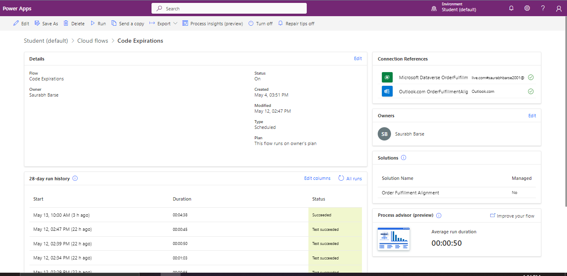

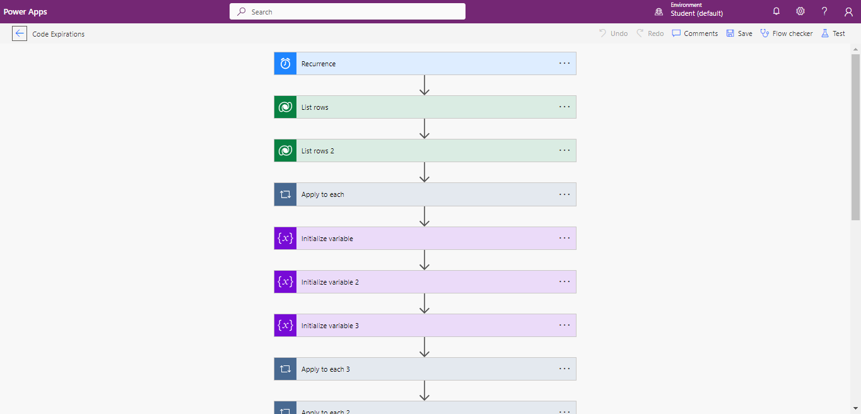

Note: Can’t show work in detail due to company confidential policy

**Result and Conclusion**

We learn and develop the critical and efficient Model driven and Canvas Application which can able to Automate and track the various billings of the resources. Hence we saved and improved the firm efficiency to track there resource billing by a Power-apps.